What is Critical Reflection?

“Reflection activities provide the bridge between community service activities and the educational content of the course. Reflection activities direct the student’s attention to new interpretations of events and provide a means through which the community service can be studied and interpreted, much as a text is read and studied for deeper understanding.”
(from R. Bringle & J. Hatcher (1999) “Reflection in Service Learning: Making Meaning of Experience”

Critical Reflection Goal = Thinking Critically

Critical Thinking Standard | Description | Associated questions to ask to check your thinking
Integration | Service experience clearly related to the learning | - Have I clearly shown the connection between my experience and my learning?
Clarity | Expands on ideas, express ideas in another way, provides examples or illustrations where appropriate. | - Did I give an example?  - Is it clear what I mean by this?  - Could I elaborate further?
Accuracy | All statements are factually correct and/or supported with evidence. | - How do I know this?  - Is this true?  - How could I check on this or verify it?
Precision | Statements contain specific information | - Can I be more specific?  - Have I provided sufficient detail?
Relevance | All statements are relevant to the question at hand; all statements connect to the central point. | - How does this relate to the issue being discussed?  - How does this help us/me deal with the issue being discussed?
Depth | Explains the reasons behind conclusions and anticipates and answers the questions that the reasoning raises and/or acknowledges the complexity of the issue. | - Why is this so?  - What are some of the complexities here?  - What would it take for this to happen?  - Would this be easy to do?
Breadth | Considers alternative points of view or how someone else might have interpreted the situation. | - Would this look the same from the perspective of….?  - Is there another way to interpret what this means?
Logic | The line of reasoning makes sense and follows from the facts and/or what has been said. | - Does what I said at the beginning fit with what I concluded at the end?  - Do my conclusions match the evidence that I have presented?"
Significance | The conclusions or goals represent a (the) major issue raised by the reflection on experience. | - Is this the most important issue to focus on?  - Is this most significant problem to consider?
Fairness | Other points of view are represented with integrity (without bias or distortion) | - Have I represented this viewpoint in such a way that the person who holds it would agree with my characterization?

Modified source: Paul, R & Elder, L. 2001. The Miniature Guide to Critical Thinking. The Foundation for Critical Thinking.

Un-critical Thinking: An Example

“Everybody knows that smoking is bad, so parents shouldn’t smoke when they have children;
those parents who do smoke obviously just don’t care about their kids.”

“[S]moking is bad.”

What do you mean by "bad?" Bad for the children's health right now because they are inhaling second-hand smoke? Bad because the parents are modeling behavior that, if imitated by the children later on in life, could harm their children's health? Bad because the parents are modeling an unhealthy behavior that could send a message to their children that it’s okay to engage in risky activities more generally?
- Failure to provide that clarity makes it hard to develop the learning much further. Clarity, therefore, can be an important "gate keeper" to learning.

“Everybody knows...”
How do you know this? What is your evidence?
- A failure to provide evidence to support the accuracy of a claim can undermine the claim itself and any conclusions that are drawn from it. The student could have cited the Surgeon General's warnings that have been on cigarette packages for years, along with hundreds of public service announcements on TV, articles in the mass media, etc. While this is not likely to be a debatable statement (except to some plaintiffs' lawyers!) it still needs documentation so that its accuracy can be confirmed.

“[T]hose parents who do smoke obviously just don’t care about their kids.”

Is it really that simple? What are some of the complexities here? For example, nicotine is addictive so it can be very hard to quit. Smoking cessation medications, such as nicotine patches, are very expensive and the parents in question may not be able to afford it. Is it fair to single out this one behavior as evidence of a parent’s attitudes? Is this the only or most important criterion against which to judge parental concern?
- Suggesting that all people who smoke around their children do not care about their children is the kind of oversimplification that should raise a red flag about the depth of someone’s thinking.
From Ash, Clayton, and Moses (2006). “Learning through Critical Reflection: A Tutorial For Service-Learning Students”

How do I get there?
How can I Structure my Reflection?

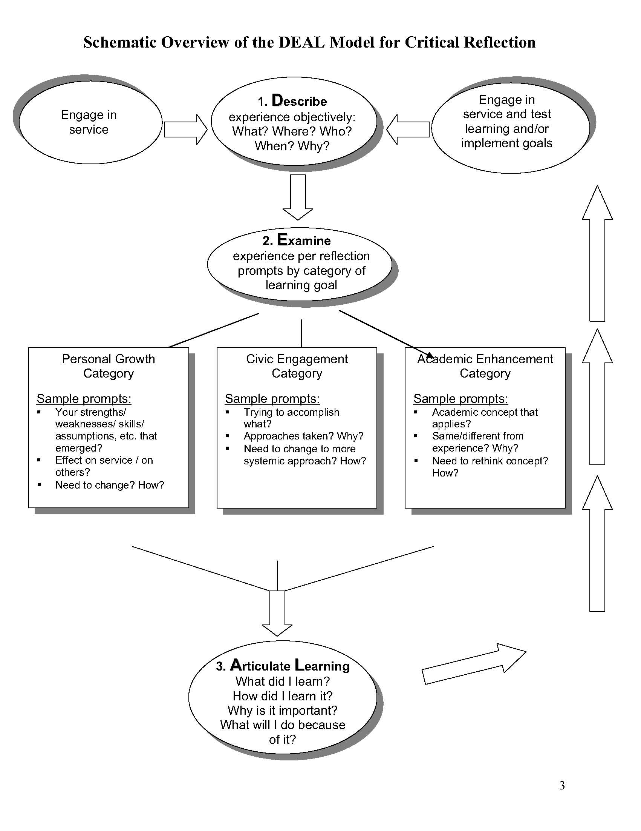
How will my reflection be assessed?

REFLECTION  RUBRIC | N/A  1 | NOVICE  2 | PROFICIENT  3 | ADVANCED  4 | DISTINGUISHED  5
Academic Concepts/Content/Learning Objectives | Little to no evidence. | Vague allusion to concepts. | Accurate knowledge of concepts. | Explores concepts in depth. | Establishes original thoughts in content/ concepts.
Experience | Little to no evidence. | Vague description of experience(s). | Accurate description of experience(s). | Explores experiences in depth. | Establishes original thoughts and insights about the experience(s).
Connections:  Synthesis of Concepts and Experience | Little to no evidence. | Vaguely linked concepts to experiences. | Clarity in making connections between concepts and experiences. | Explores connections in depth. | Establishes original thoughts and insights about the connections.
Communicate with Audience | Little to no evidence. | Vague awareness of audience.  Lacks clarity of presentation. | Clear awareness of audience. Presentation is direct and to the point. | Engages audience in subject matter. | Influences and inspires audience thinking about subject matter.
Verve:  Energy and Enthusiasm in the Expression of Ideas | Little to no evidence. | Some effort to project energy and enthusiasm. | Clear efforts to project energy and enthusiasm. | Effort to project energy and enthusiasm sustained throughout. | Energy and enthusiasm expressed with eloquence, creativity and originality.

Koliba, C. 2004. Assessing Reflection Assignments for Public Affairs Courses:
Implications for Educating Reflective Practitioners. Journal of Public Affairs Education.

This rubric was co-created by Jean Berthiaume, Tom Fluery, Mary Town,
Mary Whalen, and Christopher Koliba.

